**2 CM Duplex:(Eth0) 172.23.24.123, 172.23.24.124 (***2 CM phai cung timezone hoac NTP voi nhau***). Upload Authen file tren ca 2 CM**

**Alias: 172.23.24.125**

**Neu muon restore cau hinh cu thi phai cau hinh active-standby truoc, sau do moi restore cau hinh len tung con**

**Eth1: ip ao de 2CM dong bo voi nhau (khong nhat thiet phai ra mang dc nhung phai cung subnet)**

**Alias(Eth1): Ip ao (cung subnet voi ip eth1)**

**Tren CM 172.23.24.123**

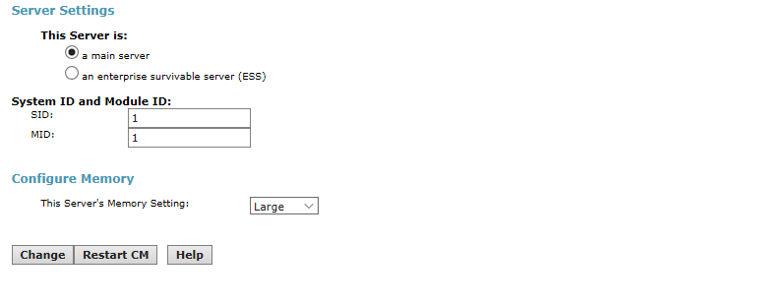

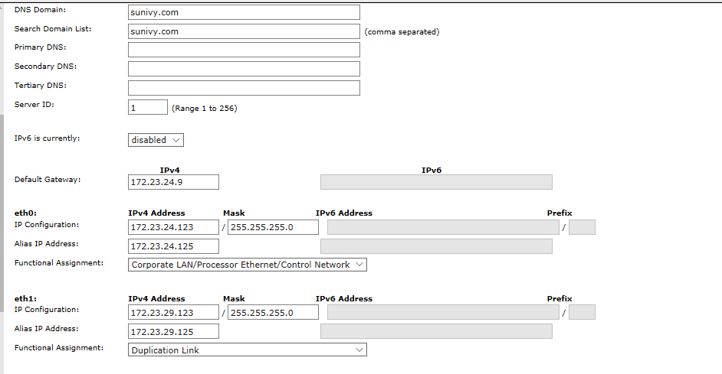

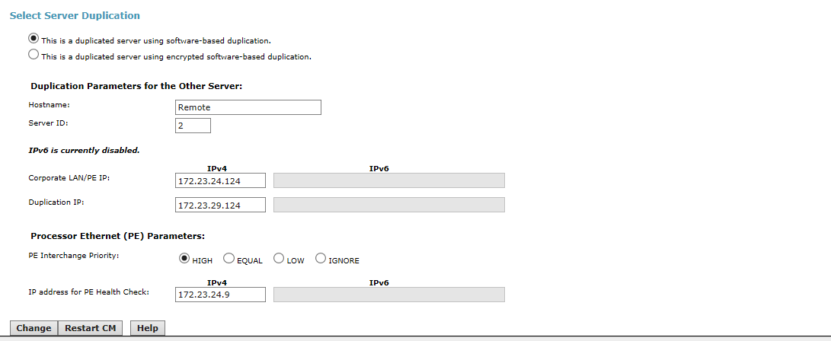

**Tren CM 172.23.24.124**

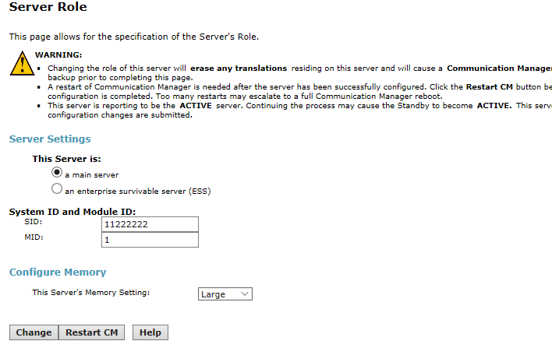

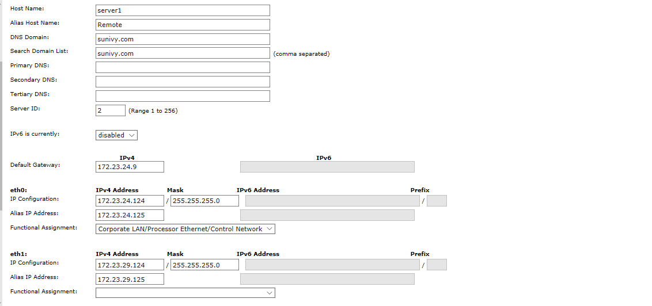

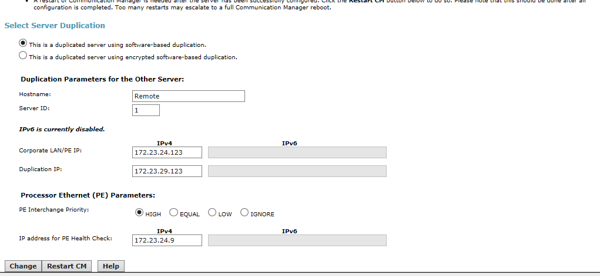

**Interchange Server**

Cho phep chuyen Server tu **active** sang **standby (doi voi CM dang active)**

**Tren CM Alias (Chuyen doi 2 Server)**

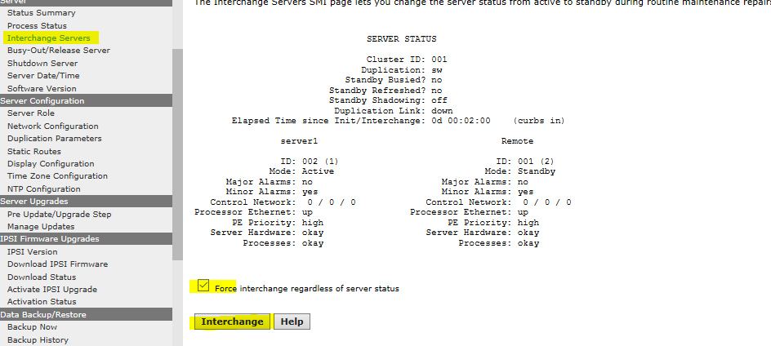

Kiem tra thoi gian chuyen Acitve-Standby tren CM

